State of Environment Report Year
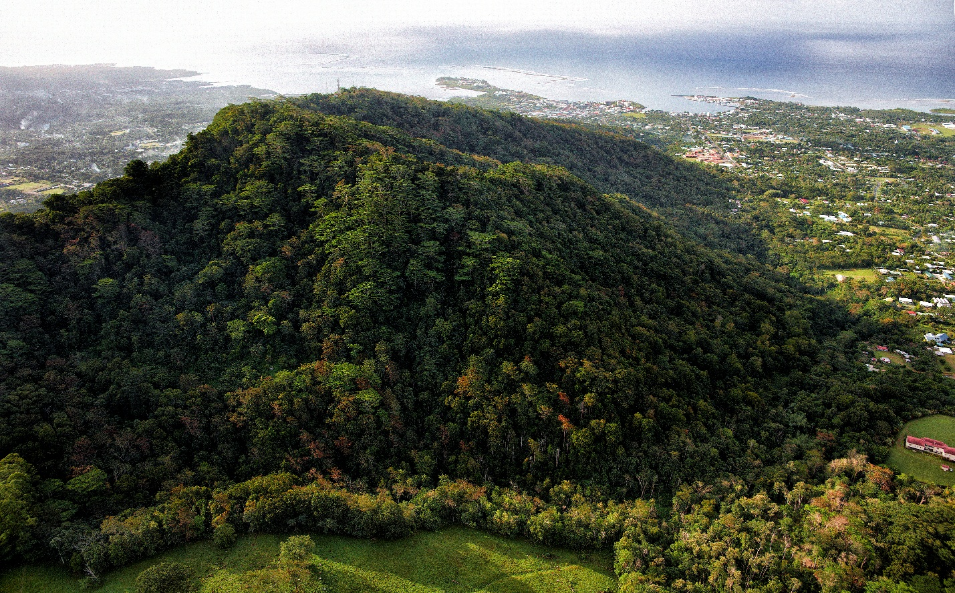
Please replace the photo below with one from the country and if possible, relevant to environmental issues included in the report. Please also credit the photographer, if possible.

Photo: © Stuart Chape

Message from the Minister/PM/Director of country
Relevant official to write message.

Message from Director of SPREP
Message is updated for each country report.
Foreword
The natural environment has always been part of Pacific island cultures. It has shaped and influenced our way of life over the centuries and as the primary source providing for our Pacific communities, it has fed, clothed and kept us safe over the years.
Despite its immense value, our environment is under growing pressure due to economic development, tourism expansion and the threat of global climate change. Therefore, it is important that we continue monitoring and maintaining the quality of our environment for future generations.
The Year and Country State of Environment (SoE) Report updates the last report completed in year, if applicable. The report assesses seven themes as well as the baseline information for new and emerging environmental challenges.
This report places the emphasis on data-based conclusions and presents supporting evidence for all indicators.
The Year SoE Report is a new baseline for future reports and can help the country with national, regional and international reporting obligations, including multi-lateral environmental agreements. This report has already informed environmental planning and decision-making, and has guided the development of the National Environmental Management Strategy.
SPREP is pleased to have partnered with the country’s environmental department name in developing this document, as well as the many other agencies and civil society organisations that contributed to the consultative process.
I would like to sincerely thank the individuals and all the government ministries and departments for their contributions. It is important that regular updates to this SoE Report are conducted to assess country’s environmental conditions. I encourage you all to use this report to help track, manage, plan and report on natural resources and the environment.

Kosi Latu
Director General
Secretariat of the Pacific Regional Environment Programme

Executive Summary
The Year State of Environment (SoE) Report for country updates Year SoE Report (if applicable), and uses the Drivers, Pressures, State, Impact and Response (DPSIR) model of reporting. The main aims of this report are to:
- Identify the key drivers and pressures behind the changing environment in country;
- Update the assessment of the country’s environment since the year SoE Report (if applicable) through use of the best available information for seven key thematic areas: Atmosphere and Climate, Inland Waters, Land, Marine, Biodiversity, Culture and Heritage, and Built Environment;
- Document the social, economic and environmental impacts that result from changes in the state of the environment;
- Document current responses by country to address changes in the state of the environment that better protect and manage resources; and
- Provide recommendations for country to address key challenges and build on existing strengths, which are linked to actions outlined by the National Environmental Strategy (NEMS).
This report is comprised of three discussions:

- Drivers and Pressures in country: A summary of the main points discussed in the Pressures and Drivers section of the report.

- The State of Environment and Impacts on the Society, Economy and Environment: Key findings for each of the seven themes.

- Responses and Recommendations – Challenges in Moving from Policy to Action: This presents key responses, opportunities, challenges and recommendations.

Drivers and Pressures in country:
Country is rapidly changing and so is the environment. The changes are driven by broader social, economic, technological and cultural forces referred to as ‘drivers’. These include population growth, urbanisation, tourism, increased access to external markets, a growing middle class, the clash of traditional and contemporary values, and greater access to technology. The drivers are a source of further pressure on the environment but they can also offer potential solutions to problems.

The pressures on the environment fall into three categories for the SoE Report:

- Land Development (urban, agricultural and coastal);
- Resource Extraction (commercial fishing and mining/quarrying); and
- Consumption and Waste (energy, solid and liquid waste, and water).

Information about pressures specific to country.

The State of Environment in country and Impacts on the Environment, Society and Economy:

Information was gathered from local stakeholders and experts on the seven major themes to provide a summary of the state, impact and response to number of topics. A brief synopsis is included at the beginning of each theme for a quick review. The following provides a summary of each major topic covered in the SoE Report:

Atmosphere and Climate
Example topics, and they can be tailored to each country:

Greenhouse Gases (GHGs): Information specific to country.

Ozone-depleting Substances: Information specific to country.

Physical Climate and Climate Trends: Information specific to country.

Climate Adaptation: Information specific to country.

Water
Example topics, and they can be tailored to each country:

Lakes: Information specific to country.

Rivers: Information specific to country.

Streams: Information specific to country.

Land
Example topics, and they can be tailored to each country:

Forests: Information specific to country.

Agriculture: Information specific to country.

Wetlands: Information specific to country.

Marine

Example topics, and they can be tailored to each country:

Offshore Environment: Information specific to country.

Inshore Environment: Information specific to country.

Biodiversity
Example topics, and they can be tailored to each country:

Endemic, Native and Threatened Species: Information specific to country.

Environmental Invasive Species: Information specific to country.

Terrestrial-protected Areas: Information specific to country.

Built Environment
Example topics, and they can be tailored to each country:

Energy: Information specific to country.

Municipal Solid Waste: Information specific to country.

Hazardous Wastes: Information specific to country.

Potable Water: Information specific to country.

Sewage and Sanitation: Information specific to country.

Culture and Heritage
Example topics, and they can be tailored to each country:

Built Heritage and Indigenous Sites: Information specific to country.

Language: Information specific to country.

Traditional Production and Consumption of Food: Information specific to country.

Traditional Environmental Knowledge: Information specific to country.

Responses and Recommendations: Challenges in Moving from Policy to Action.
Information specific to country.

Acknowledgments

Introductory information specific to country.

COORDINATION AND PLANNING

ENVIRONMENTAL DEPARTMENT NAME

SPREP
People who contributed

WRITING, ANALYSIS, DESIGN AND COMPILATION
People who contributed

KEY CONTRIBUTORS
People who contributed

OTHER RELEVANT AGENCIES
People who contributed

Other Offices and Organisations

Offices

Other relevant agencies and offices

Institutions and Organisations
Other relevant agencies and offices

SPREP Staff
People who contributed.

Many additional people have contributed to this document and we acknowledge and thank everyone. We apologies for any omissions.

Table of Contents

Page numbers and content modified for each country report.

Section 1: Introduction, background and highlights of the Year SoE Report
Acknowledgements:

Introduction and background:

Overview of SoE Report objectives, regulatory and planning context, DPSIR Model, and themes
- Brief overview of Year SoE Report process
- Comparing the Year and Year SoE Reports (if applicable)
- Glossary of Terms
A Reader's Guide to the Year State of Environment Report
Section 2: Drivers and Pressures
What are the main drivers behind environmental change in the Country?
- Five Drivers with global, regional and national indicators:
  - Population and Migration
  - Globalisation and Geography
  - Economic and Technological Development
  - Traditional and Contemporary Values, Attitudes, Lifestyles and Governance
  - Climate Change and Variability
What are the major pressures on the Country environment?
- Three categories with national indicators:
  - Land Development
  - Resource Extraction
  - Consumption and Waste
Section 3: The State of the Environment
State of the Environment by Theme, includes the State, Impact and Response to Indicators within seven themes, subdivided into topics:
- Atmosphere and Climate
Example topics, and they can be tailored to each country:
  - Ozone-depleting Substances (ODS)
  - Greenhouse Gases (GHGs)
  - Climate Adaptation
  - Physical Climate - Temperature, Precipitation, Flooding, Droughts,
Sea Level and Cyclones

- Water
Example topics, and they can be tailored to each country:
  - Surface Water Quality
  - Groundwater

- Land
Example topics, and they can be tailored to each country:
  - Naturally Vegetated Areas and Plantations
  - Agriculture
  - Wetlands

- Marine
Example topics, and they can be tailored to each country:
  - Offshore Marine Environment
  - Inshore Marine Environment
  - Marine-managed Areas

- Biodiversity
Example topics, and they can be tailored to each country:
  - Terrestrial Protected Areas
  - Environmental Invasive Species
  - Endemic and Native Species
  - Species of Concern

- Built Environment
Example topics, and they can be tailored to each country:
  - Drinking Water
  - Sanitation and Sewage
  - Solid Waste Management, Collection and Recycling
  - Hazardous Waste
  - Energy Consumption and Renewables

- Culture and Heritage
Example topics, and they can be tailored to each country:
  - Language
  - Traditional Consumption and Production
  - Historical Sites
  - Traditional Knowledge
Section 4: Summary and Recommendations of the Year and Country SoE Report
- Conclusion
- Recommendations: Building on Successes and Strengthening Weaknesses

Acronyms:
List can be tailored to each country.

ADB Asian Development Bank
AFB Adaptation Fund Board
AIACC Assessment of Impacts and Adaptation to Climate Change
ANZAC Australian and New Zealand Army Corps
AusAID Australian Agency for International Development
CBD Convention on Biological Diversity
CBDAMPIC Capacity Building for the Development of Adaptation Measures in Pacific Island Countries
CCRC Centre for Cetacean Research and Conservation
CFC Chlorofluorocarbon
CH₄ Methane
CHARM Comprehensive Hazard and Risk Management
CLIMAP Climate Change Adaptation Programme for the Pacific
CMS Convention on the Conservation of Migratory Species of Wild Animals
CO₂ Carbon dioxide
COT Crown of Thorns (starfish)
DO Dissolved Oxygen
DPR Daily Pollution Release
DPSIR Drivers, Pressures, State, Impact and Response
DRM Disaster Risk Management
EEZ Exclusive Economic Zone
EIA Environmental Impact Assessment
EbA Ecosystem-based Adaption
EU European Union
FAO Food and Agriculture Organization of the United Nations
FSSLP Food Security for Sustainable Livelihoods Programme
GCRMN Global Coral Reef Monitoring Network
GDP Gross Domestic Product
GEF Global Environment Facility
GFDRR Global Facility for Disaster Reduction and Recovery
GHG Greenhouse Gases
HCFC Hydrochlorofluorocarbons
HFC Hydrofluorocarbons
IBA Important Bird Areas
INDC Intended Nationally Determined Contribution
IPPC International Plant Protection Convention
JNAP Joint National Action Plan
KBA Key Biodiversity Areas
KPAF-SRIC Kyoto Protocol Adaptation Fund Project Proposal Strengthening Resilience of Our Islands and Communities
MEA Multilateral Environment Agreement
MMA Marine-managed Area
MOA Ministry of Agriculture
MOIF Ministry of Infrastructure and Planning
MOU Memorandum of Understanding
MPA Marine Protected Area
MSY Maximum Sustainable Yield
NA Nesting Aggregation
NBSAP National Biodiversity Strategic Action Plan
NEMS National Environmental Strategy
NESAF National Environment Strategic Action Framework
NGO Non-governmental Organisation
NH₄ Ammonium
NMDI National Minimum Development Indicator
N₂0 Nitrous Oxide
NO₃ Nitrate
NSDP National Sustainable Development Plan
NZAid New Zealand Agency for International Development
NZD New Zealand Dollar
ODS Ozone-depleting Substances
OPM Office of the Prime Minister
PACC Pacific Adaptation to Climate Change
Pa Enua Outer Islands
PASAP Pacific Adaptation Strategy Assistance Programme
PCRAFI Pacific Catastrophe Risk Assessment and Financing Initiative
PFC Perfluorocarbons
PIC Pacific Island Countries
PROCFish Pacific Regional Oceanic and Coastal Fisheries Programme
SF₆ Sulphur hexafluoride
SoE State of Environment
SOPAC Pacific Islands Applied Geoscience Commission
SPC Secretariat of the Pacific Community
SPCZ South Pacific Convergence Zone
SPREP Secretariat of the Pacific Regional Environment Programme
SST Sea Surface Temperature
SUP Sanitation Upgrade Project
SWOT State of Worlds Sea Turtles
TREDS Turtle Research and Monitoring Database System
TSS Total Suspended Solids
UNDP United Nations Development Programme
UNFCCC United Nations Framework Convention on Climate Change
USD US Dollar
UVC Underwater Visual Census (survey method)
VCA Vulnerability and Capacity Assessment
WATSAN Water Waste and Sanitation Unit of ICI
WCPFC Western and Central Pacific Fisheries Commission
WCPO Western and Central Pacific Ocean
WWF World Wildlife Fund

SECTION 1:
Introduction and Reader's to Guide the Year SOE
Text developed for each country.

Introduction and Background

Environmental reporting in the Country
Information specific to the country.

Purpose of the State of Environment Report
The purpose of the country SoE Report is to present the best available information about the current state of the environment as the basis for effective environmental management and planning (The SoE Report examines the major drivers of change to the environment that emerge from global, regional and national factors. The SoE Report evaluates the main environmental pressures created by these drivers, and examines their social, economic and environmental impacts.
State of Environment (SoE) reporting is an internationally accepted reporting method that analyses the condition of a geographic area or jurisdiction’s ecosystems, and associated natural resources. SoE Reports compile and analyse quantitative and qualitative data from a variety of local, national, regional, and international sources to provide a holistic picture of a location’s current state of the environment. SoE Reports also identify environmental trends, including anthropogenic impacts to natural environments.
SoE Reports prioritise the most important environmental attributes of a given location and identify issues that impact the state of the location’s environment. The reports have included the condition of flora and fauna species as well as habitats such as native forests, marine and inland water bodies, soils, and vegetation cover. The reports also address key aspects of highly modified agricultural and built environments.
Many SoE Reports predict a location’s future state, which is often related to problems within that environment. These predictions can help to address growing concerns about the impacts of climate change by offering an idea of the future state of the environment under ‘business as usual’ scenarios. This can inspire climate change adaptation and mitigation strategies that address emerging issues and threats. SoE Reports can also provide well-researched information for local, municipal, and national planners and managers in areas such as natural resource management, town and urban planning, tourism, and resource development (Figure 2).

Audiences
The main audiences for the country SoE Report are:
- Country government personnel, particularly in areas relating to the environment, planning and infrastructure, health, and education
- Citizens and community groups
- Donor organisations
- Non-governmental organisations e.g. local example here
- Research institutions and universities, and researchers with interests specific to the SOE report’s thematic areas

Comparing the last version of SoE Report (if applicable) and Year State of Environment (SoE) Reports:
The Year State of Environment (SoE) Report updates the last version of SoE Report (if applicable) with a focus on data collected in the interim between the reports. Include more information specific to country, if relevant.

Approach to the Year Country SoE Report

The Drivers, Pressures, State, Impact and Response (DPSIR) Model in SOE reporting
The Drivers, Pressures, State, Impact and Response (DPSIR) model (Figure 1) is used in SOE reporting. The model is a global standard for State of Environment reporting and part of a systems approach that takes into account social, political, economic, and technological factors, as well as forces associated with the natural world.

Figure 1: SoE Report Framework (DPSIR Model)
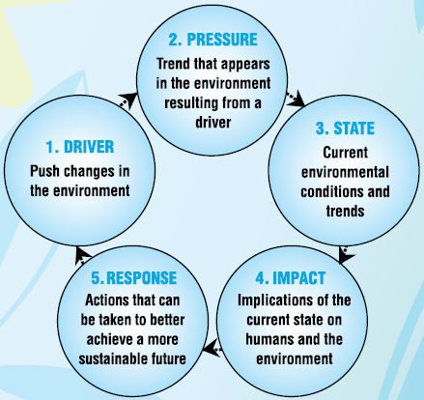

Themes for the Country Year State of Environment Report
The Year SoE Report includes seven thematic areas with important ecosystems and environmental issues addressed under each theme. Themes were divided into habitats or sub-topics, and indicators were developed for each one. For example, the Marine Environment theme is divided into three sub-topics: list topics specific to country.
The indicators for each habitat or sub-topic are used to assess the state of that specific habitat or sub-topic (Table 1). For example, the sub-topic specific to country has four key indicators: specific to country. The indicators are individually rated for State (Good, Fair, Poor), Trend (Deteriorating, Stable, Mixed, Improving) and Confidence in the Data (Low, Medium, High). The indicators are then integrated into the sub-topics under each theme (highlights section), and a similar rating for State, Trend and Confidence is assigned to each theme. For more information, refer to A Guide to Interpreting State, Trend and Confidence Symbols (page specific to each report).

Table 1. Themes, sub-topics and indicators for the Year Country SoE Report

Theme | Sub-Topic or Area  Examples included, but tailor to be specific to country | Indicator (s)  Examples included, but tailor to be specific to country
Atmosphere and Climate | Greenhouse Gas (GHG) Emissions | GHG emission trends and mitigation efforts to date  Table 0-1. Themes, sub-topics and indicators for the 2014 Cook Islands SOE Error! Bookmark not defined.
 | Ozone-depleting Substances | ODS consumption trends and reduction efforts to date
 | Physical Climate and Climate Trends | Mean, max and min temperature trends
 |  | Mean, max and min precipitation trends
 |  | Sea level rise over time
 |  | Cyclone frequency and intensity
 |  | Flood and drought occurrence over time
 | Climate Adaptation | Water security adaptation actions
 |  | Food security adaptation actions
 |  | Health adaptation actions
 |  | Land use policies
 |  | Climate proofing infrastructure and buildings
Inland Waters  Inland Waters | Streams | Stream water quality and flow
Land  Land | Forests | Forest area, and types naturally vegetated areas and trends over time
 | Agriculture | Percent of land under cultivation or other agricultural use
 | Wetlands | Wetland areas and trends over time
Marine | Offshore Environment | Tuna, tuna-like species and sharks harvested
 | Inshore Environment | Live coral cover
 |  | Reef fish and urchin density and biomass
 |  | Reef fisheries
 |  | Marine-managed areas
 |  | Lagoon water quality
 | Turtles and Cetaceans | Turtle movement and nesting
 |  | Cetacean movement and abundance
Biodiversity | Endemic and Native Species | Status of endemic and native species
 | Environmental Invasive Species | Status of spread and control of environmental invasive species
 | Key Species of Concern | Status of species from case studies
 | Terrestrial-protected Area | Status of terrestrial protected areas
 | Energy | Access, sustainability and efficiency  Energy consumption, availability and renewables
 | Municipal Solid Waste | Collection, recycling and waste separation
Built Environment | Hazardous Waste | Management and collection of hazardous waste, E-waste, white goods, asbestos, batteries and household
 | Potable Water | Access and quality of drinking water
 | Sewage and Sanitation | Access and quality of sewage treatment
Culture and Heritage | Built Heritage and Indigenous Sites | Historical sites’ status and protection
 | Language | Traditional spoken language
 | Traditional Production and Consumption of Food | Consumption and production of traditional foods
 | Traditional Environmental  Knowledge | Practice and production of traditional medicines, knowledge and crafts

No | Thematic Content | Thematic Lead
1 | Atmosphere and Climate
2 | Inland Waters
3 | Land
4 | Marine: (Inshore & offshore )
5 | Biodiversity
6 | Built Environment
7 | Culture and Heritage

A Reader's Guide to the

Year State of Environment Report
How to read the report:
A State of Environment report condenses a large amount of information on various aspects of the environment into a readable and actionable report. Given the broad spectrum of topics covered, the report has been broken into themes for easier utilization. The report can be read as a whole, or according to different themes, noting that most of the themes are connected to each other and to the pressures and drivers behind them. Symbols were designed for each indicator to summarise the State, Trend and Confidence in each assessment. Symbols were also designed for groups of indicators that describe a habitat or sub-topic within a theme. For example, the Land theme is broken into examples specific to country. Symbols were not designed for each theme because the variety of potential states limits a meaningful summary statement.
Guide to the symbols used:
SoE Report assessments integrate many data sources and expert opinions. For the country SoE Report, there may not be enough information available to make quantitative assessments of the state of an environment using, for example, an index of 1 -10, or a quantitative threshold figure, that could be compared across themes. Consequently, a generic index was developed that used expert opinions and best available data to inform ‘Status’ ratings of either ‘Good’, ‘Fair’, and ‘Poor’.
Assessment symbols (Figure 2) summarise the ‘State’ of each indicator. The assessment symbols establish baselines to compare the state of each indicator for future assessments, including SoE Reports. The symbol includes ratings for ‘Status’, ’Trend’ and ‘Confidence’. Table 2 provides a guide to interpret the symbols, and explains how the symbols were derived.
Figure 2: Explanation of the Indicator symbol
Colour indicates state of Good, Fair and Poor (can be a range)
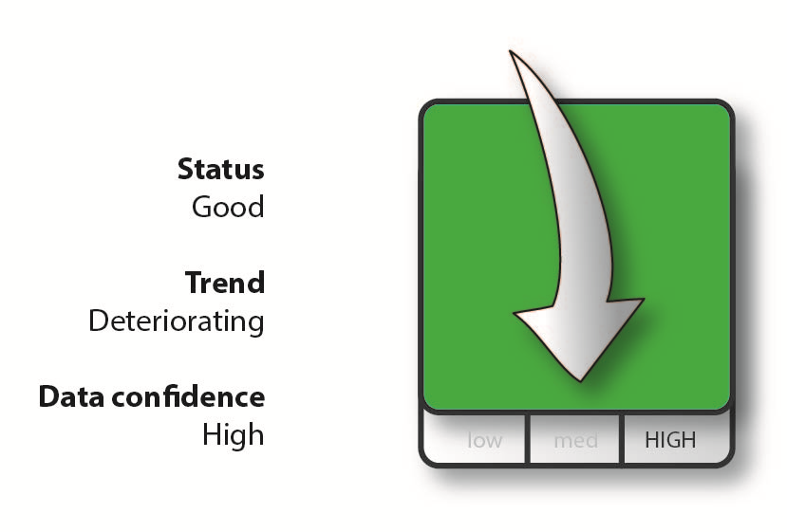

Arrow indicates trend of Improving, Stable, Deteriorating, Undetermined and Mixed

Bottom bar of Low, Medium and High indicates confidence in data and assessment

Table 2. Guide to interpreting the symbols

 | Category | Description | How is it derived? | Symbol Example
State  (can be a range) | Good | The level to which the indicator meets or exceeds (good), is close to meeting (fair) or is well below (poor) a given standard for healthy ecosystems, habitats, species, airsheds, watersheds or an urban environment. | Assessment is based on 1) recent trends, 2) comparison with similar jurisdictions, and 3) comparison with ‘healthy’ habitats and systems. Where limited data exists to make an assessment based on these criteria, expert opinion is used.
 | Fair
 | Poor
Trend | Improving | The state of the environment related to this indicator is getting better. | Trends show a significant increase, or based on weight of evidence that indicators are improving.
 | Deteriorating | The state of the environment related to this indicator is getting worse. | Trends show a significant decrease, or based on weight of evidence that indicators are worsening.
 | Stable | The state of the environment related to this indicator shows there is no detectable change. | Trends show no significant increase or decrease, or, based on weight of evidence that indicators are stable.
 | Mixed | The state of the environment related to this indicator shows a mixed trend: sometimes the state is getting better, worse, or there is no change. | Used primarily for sub-topics with multiple indicators, or in cases where data shows two distinct trends.
 | Undetermined | Not enough data exists to determine trend. | Insufficient data available to generate trend.
Confidence | High | Data is of high quality and provides good spatial and temporal representation. | Trusted and comprehensive time series and/or national level data sources are used to determine confidence trend.
 | Medium | Data is either lower quality, geographically sparse or limited temporally. | Data is derived from many sources, and is not always consistent, with some extrapolation necessary.
 | Low | Data does not meet any of the above criteria. | Data is very coarse and outdated, and limited to single country sites.

SECTION 2: Drivers and Pressures on Country Environment

What are the Drivers of Environmental Change in the Country?
Human activities, such as urban development and overfishing, are placing pressures on the natural environments of the Pacific islands and their exclusive economic zones (EEZs). These activities are driven by broad social, economic, technological and cultural forces. These drivers interact to produce changes in the environment, which impact the livelihoods and well-being of individuals, communities and nations. The Year and Country SoE Report identifies five broad-level drivers of environmental change (Table 3).
Drivers can be changed to fit country.
- Population demographics and migration;
- Globalisation and geography;
- Economic and technological development;
- Traditional and contemporary values, attitudes, lifestyles and governance; and
- Climate change and variability.

Table 3: Country environmental drivers and key indicators used in the SoE Report

Drivers | Population Demographics and Migration | Globalisation & Geography | Economic and Technological Development | Traditional & Contemporary Values, Attitudes, Lifestyles & Governance | Climate Change and Variability
Key Indicators | Regional and national population changes | Shipping patterns and connectivity | Access to Internet and cell phones | Trends in traditional cooking | Global CO₂  emissions
 | Migration trends | Tourism arrivals in country and regional tourism comparisons | Global and national economic trends | Trends in access to foreign and national education | Global average air temperatures and sea surface temperature
 | Household composition |  | GDP per capita and income distribution - the Pacific region and country
Drivers can have diverse social, economic and environmental impacts; are not exclusively negative or positive; and should be viewed objectively with respect to their various management contexts.
Driver 1: Population Demographics and Migration
Example text and graphic, and content should be tailored to each country.

Population growth is a major driver of changes to the environment with pressures on both the built and natural environment. Figure 5 shows the historic, current and projected populations for the Pacific region from 1970 to 2050. Polynesia and Micronesia have lower historic and projected growth rates compared to Melanesia, in particular Papua New Guinea.

Add more figures and text relevant to country.

Driver 2: Geography and Globalisation
Specify driver and add figures and text relevant to country per Driver 1 example.

Driver 3: Economic and Technological Development

Specify driver and add figures and text relevant to country per Driver 1 example.

Driver 4: Traditional and Contemporary Values, Attitudes and Lifestyles

Specify driver and add figures and text relevant to country per Driver 1 example.

Driver 5: Climate Change

Specify driver and add figures and text relevant to country per Driver 1 example.

What Environmental Pressures are the Drivers Creating?

This section highlights the key pressures on the country’s environment and society created by the overarching drivers identified in the previous section. Pressure indicators present data about the main human activities that could adversely affect the environment, and each indicator is linked to at least one of the drivers. Pressure indicators are organised using three classifications: land development, resource extraction, and consumption and waste (Table 4). Some pressures will be covered in the ‘State’ section.

Table 4. Key environmental pressures in the Country

Issues can be tailored to country.
Pressures | Land Development | Resource Extraction | Consumption and Waste
Key Indicators | Formal Urban Development | Land use and forestry | Energy consumption
 | Agriculture | Fishing | Vehicle ownership
 | Invasive Species | Aquaculture | Solid and Liquid Waste Generation
 |  |  | Water consumption

Pressure 1: Land Development
Pressure and text can be tailored to country.

Sources:
Include any relevant sources.

SECTION 3:
STATE of COUNTRY ENVIRONMENT,
IMPACT, and CURRENT and RECOMMENDED RESPONSES

Fill in text as relevant to country.

THEME 1: ATMOSPHERE AND CLIMATE

All text in this section should be changed and tailored to the country, but it is included to serve as an example of what information should be included.
Further notes are included for specific parts of this section to show what the text is illustrating and how it should guide a country in preparing the SoE Report.
These gray boxes with instructive text should be deleted once the template is completed for the country.

The highlighted overview text gives background on the current conditions related to Atmosphere and Climate in the example country.

Overview

This chapter on the state of Cook Islands’ Atmosphere and Climate focuses on four areas: Greenhouse gases (GHGs); Ozone-depleting Substances (ODS); Physical Climate and Climate Trends (air temperature, precipitation, and extreme climatic events); and Climate Adaptation (food security, water security, health and flood risks).
Through the greenhouse effect, the increase in the concentration of GHGs in the atmosphere has been shown to influence climate change, which results in more intense storms and droughts, and higher sea level and temperatures. The Cook Islands National Energy Policy seeks to achieve 100% renewable energy by 2020. As of 2014, five per cent of the country’s energy comes from renewable sources, thus it is necessary to prioritise the development of the renewable energy sector. Cook Islands phased out ODS over the last decade and has fully complied with the Montreal Protocol. Chlorofluorocarbons (CFCs) were phased out in 2010 and Cook Islands is ahead of schedule in phasing out Hydrochlorofluorocarbons (HCFCs) by 2030, with a current import level of 0.3 metric tonnes in the third quarter of 2014. Climate adaptation is recognised as a priority and Cook Islands is assessing the vulnerability of each of its islands.

ATMOSPHERE AND CLIMATE HIGHLIGHTS
The chart below summarizes what topics, their status and trend, key findings, and the response and recommendations being carried out related to Atmosphere and Climate in the example country.

Cook Islands should maintain its strong response to reducing ODS, particularly HCFCs, and build on its past successes particularly with CFCs. Cook Islands should offer regular refresher training courses for technicians under the National Ozone Unit’s training course, and should keep records of ODS imports and exports. The Renewable Energy Chart aims to reach 100% renewable sources of electricity by 2020. Programmes should be developed to reduce GHG sources from other sectors including road transport, domestic aviation and shipping. This includes investments in public transport and restrictions on certain vehicle types.
Ozone-depleting substances (ODS) have been greatly reduced, CFCs phased out, and Cook Islands is on track to phase out HCFCs.
GHGs have increased over the past 20 years. Most GHG emissions are from the energy sector, with domestic aviation, solid and liquid waste management, agriculture and industrial coolants and solvents also significant sources of GHGs.

ODS: 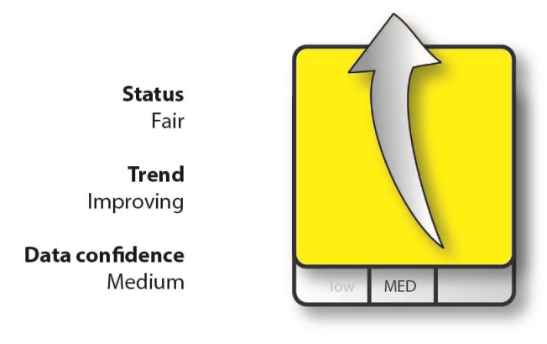GHGs: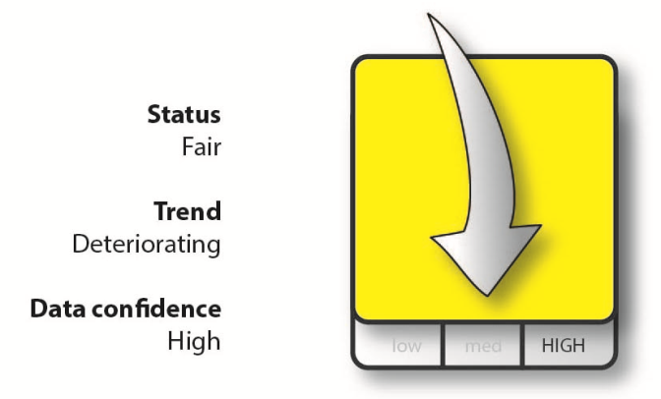

ODS and GHGs

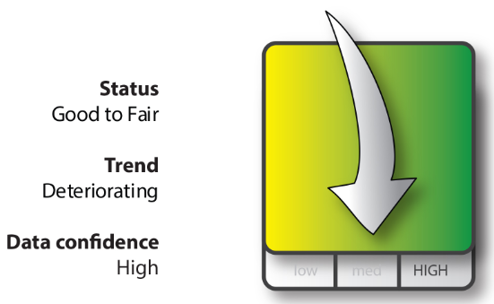
Mean and extreme temperatures and rainfall are usually higher in the northern Cook Islands, with little seasonal variation in temperature in both island groups. Cook Islands has a wet season and a dry season, and its climate is strongly affected by the South Pacific Convergence Zone (SPCZ), and by El Niño /La Niña events. Climate change projections include warming temperatures, sea level rise, ocean acidification, increased rainfall and changes in wind patterns, all of which have various environmental, social and economic impacts.

Cook Islands is committed to addressing, preparing for and mitigating climate change impacts, such as through its role as a signatory in international climate change treaties. Cook Islands should expand data collection of climate related indicators, expand disaster preparedness programmes particularly for tropical cyclones, and increase natural, ecosystem-based adaptation projects. Integration of climate change information into cross-sectoral planning and management regimes is essential to prepare for climate impacts into the future.
Physical Climate and Climate Trends

Cook Islands should continue to prioritise climate adaptation projects, and should further integrate climate proofing into future infrastructure development and policy requirements such as EIAs. There is good progress with vulnerability assessments across the country. Many climate adaptation options are likely to vary from island to island. Where possible, Ecosystem-based Adaptation (EbA) approaches should be prioritised to ensure long term adaptive, financial and environmental sustainability of adaptation projects.

Climate adaptation is recognised as a high priority, and it is being addressed by all sectors from government to NGOs and youth. This report focuses on the state and need for climate adaptation in the areas of water security, food security, health, land use and infrastructure. Climate adaptation activities can range within each of these areas. Cook Islands has made good progress in integrating climate adaptation into national and international policies, and undertaking a range of partnership projects. However, due to the many vulnerabilities and risks associated with climate change, adaptation efforts will need to remain a high priority into the future, with greater investment into adaptation projects.

Status: Fair to poor Trend: Mixed Data Confidence: Low

Climate Adaptation

Topic/Subtopic: Ozone-depleting substances

ATMOSPHERE & CLIMATE

The highlighted introductory text gives background of how the subtopic of ozone-depleting substances affects the example country.

Introduction
Stratospheric ozone is naturally generated at high altitudes (15–50km above the earth’s surface), and protects humans and other life forms from harmful ultraviolet energy from the sun. Chlorofluorocarbons (CFCs), Hydrochlorofluorocarbons (HCFCs) and other Ozone-depleting Substances (ODS) deplete the stratospheric ozone by reacting with it and breaking it down. ODS are found in many products and household items, and have a number of applications, including for refrigeration, air conditioning, solvents and fire extinguishers.

The Montreal Protocol is an international agreement designed to eliminate the production and consumption of ODS. The Montreal Protocol was adopted in 1987, and has since been revised and amended. The Cook Islands became party to the Montreal Protocol on 22 December, 2003.
The highlighted paragraph below serves as an example of how the indicator has been defined for the country example, the Cook Islands.

This indicator reviews Cook Islands’ consumption of CFCs and HCFCs since 1995, based on data provided to the United Nations Environment Programme (UNEP). Values are given in ozone depleting potential (ODP) units, which is a measure of the relative amount of degradation to the ozone layer that ODS chemicals can cause. Depending on their makeup, CFCs have anywhere from five to 200 times more ODP compared to HCFCs.

The highlighted text below serves as an example of how the country rated its status related to the sub-topic of ozone-depleting substances.

State
Status: Fair Trend: Improving Data Confidence: Medium
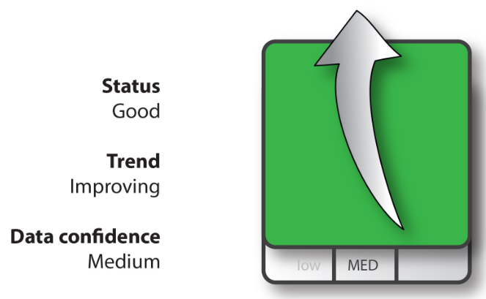
Since the 1980s, it has been estimated that four types of ozone-depleting substances have been imported into Cook Islands in bulk form. These substances are chlorofluorocarbons (CFCs), Hydrochlorofluorcarbons (HCFCs), methyl bromide and halons. CFCs and HCFCs are used for refrigeration and air conditioning, methyl bromide was used for quarantine fumigation, and halons are used for fire protection. The consumption of ozone-depleting substances in Cook Islands is exclusively in the refrigeration and air conditioning sector (NES, 2016). Due to international and national efforts, CFCs declined rapidly in Cook Islands from 1995 onward, and as of 2010, CFCs have been phased out. Data collection on HCFCs began in 2008 and shows a decline from 2010 to 2013 (Figure 52). No ODS data was collected for the Cook Islands between 1999 and 2008.
The below graphs and highlighted text provide reasoning behind the ranking for the state of ozone-depleting substances in the example country.

NO DATA 1999-2008
Figure 52: Cook Islands CFC and HCFC consumption, 1995-2013. (Source: UNEP)

The Cook Islands is working to phase out all of its HCFCs. A baseline for the import of HCFCs was based on an average of 2009 and 2010 data at 1.2 metric tonnes. In 2012, the import of HCFCs was 0.75 metric tonnes, down 39% on the 2009/2010 average. It dropped again in 2013 by 30.5% to 0.37 metric tonnes. By 2015, no HCFCs were imported. This means that Cook Islands is 15 years ahead of the phase-out schedule set by the Montreal Protocol, whose goal was 2030 to phase out 97.5% of all HCFCs (Figure 53).

Figure 53: Comparison of Cook Islands phase-out steps for HCFCs as in the Montreal Protocol (blue) with actual imports of HCFCs (red) up to the third quarter of 2014. (Source: Montreal Protocol & UNEP & pers. comm. NES)
The below highlighted text and figure explain how the current state of ozone-depleting substances in the example country will have an impact on its environmental conditions.

Impact
ODS are not only harmful to the ozone layer, they are also a potent source of Greenhouse Gases (GHGs). HCFCs have 2000-3000 times greater global warming potential than does CO₂ , although amounts in the atmosphere are much less. Phasing out ODS not only helps to protect the ozone layer, but also benefits climate change mitigation through the reduction of GHGs emissions. Figure 54 shows an empty canister of an HCFC.
As a signatory to the Montreal Protocol, there are trade implications if the Cook Islands accepts, or illegally trades, in ODS. The phase out of ODS is important for the Cook Islands’ environment, but also for its economy to protect against adverse trade implication and ensure compliance and good global standing as a signatory to the Montreal Protocol.
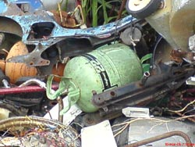

Figure 54: Disposed R22 Canister an HCFC refrigerant. (Source: NES)

The below highlighted text explains current 1) responses, which are actions being carried out by the government, and 2) recommendations, which are proposals that go into action-planning documents like the National Environment Management Strategies and Sustainable Development Action Plans.

Responses and Recommendations
Cooks Islands has phased out CFCs and is ahead of schedule to phase out HCFCs. The National Ozone Unit (NOU) updated the Environment Act to provide an ODS import quota system and include a Technicians Licence to legally service equipment containing ODS. This includes a requirement for technicians to attend training in 'Good Practices in Refrigeration' as well as refresher courses. The training covers the proper handling of ODS and educates the technicians about the importance of avoiding any gas leakages or discharges of ODS into the atmosphere. Between 2010 and 2013, the number of certified ODS recovery technicians increased from 16 to 24. A Memorandum of Understanding (MOU) between the NOU and Customs provides training to customs officials to identify and report illegally imported ODS.
Data collection and monitoring of ODS imports improved after 2008. ODS recovery equipment is available for Rarotonga, including recovery cylinders. ODS recovery and re-use is growing across Rarotonga. CusPac Customs system software helps track and detect tariff codes for ODS, which assist with monitoring and management measures.
Currently, records are not kept for ODS exports for disposal from Cook Islands. Recording ODS exports, as well as imports of ODS alternatives such as HCs and HFCs, would assists in the overall monitoring and management of ODS. Regular refresher training courses for the National Ozone Unit’s technicians would ensure their skills are up to date.

Sources:
The below highlighted list shows how sources used throughout this section were properly cited.
United Nations Environment Programme (UNEP). 2000. The Montreal Protocol on Substances that Deplete the Ozone Layer

National Environment Service (NES), Tu’anga Taporoporo, Cook Islands. Ozone Depleting Substances (ODS) phase out in the Cook Islands. http://nescookislands.com/advisory-compliance-division/ozone-depleting-substances/. 07.10.2016.
United Nations Environment Programme (UNEP). Ozone Secretariat. ODS Database. http://ozone.unep.org/. ODS Consumption in ODP Tonnes, data retrieved from database when last updated 23 September 2014.
Repeat this format for each theme and sub-topic used in the country’s SoE Report.

THEME 2: WATER

Overview
Write text relevant to country.

WATER HIGHLIGHTS

Update chart relevant to country.
KEY FINDINGS
RESPONSE and RECOMENDATIONS

STATUS and TREND
TOPIC

.

Topic/Subtopic: Lakes (Update topics as relevant to country)

WATER

Introduction

Write text relevant to country’s topic/subtopic.

State
Update status text relevant to country.

Status: Fair Trend: Deteriorating Data Confidence: High
Write text relevant to country and included related indicator icon and any graphs/figures that may be applicable.

Impact
Write text relevant to country and include any figures/graphs and/or photos that may be relevant.

Responses and Recommendations
Write text relevant to country and include any figures/graphs and/or photos that may be relevant.

Sources
Include any relevant sources.

Repeat this format for each theme chosen for the country’s report.

THEME 3: LAND

Overview
Write text relevant to country.

LAND HIGHLIGHTS

Update chart relevant to country.
KEY FINDINGS
RESPONSE and RECOMENDATIONS

STATUS and TREND
TOPIC

.

Topic/Subtopic: Forests (Update topics as relevant to country)

LAND

Introduction

Write text relevant to country’s topic/subtopic.

State
Update status text relevant to country.

Status: Fair Trend: Deteriorating Data Confidence: High
Write text relevant to country and included related indicator icon and any graphs/figures that may be applicable.

Impact
Write text relevant to country and include any figures/graphs and/or photos that may be relevant.

Responses and Recommendations
Write text relevant to country and include any figures/graphs and/or photos that may be relevant.

Sources
Include any relevant sources.

Repeat this format for each theme chosen for the country’s report.

THEME 4: MARINE

Overview
Write text relevant to country.

MARINE HIGHLIGHTS

Update chart relevant to country.
KEY FINDINGS
RESPONSE and RECOMENDATIONS

STATUS and TREND
TOPIC

.

Topic/Subtopic: Offshore Environment (Update topics as relevant to country)

MARINE

Introduction

Write text relevant to country’s topic/subtopic.

State
Update status text relevant to country.

Status: Fair Trend: Deteriorating Data Confidence: High
Write text relevant to country and included related indicator icon and any graphs/figures that may be applicable.

Impact
Write text relevant to country and include any figures/graphs and/or photos that may be relevant.

Responses and Recommendations
Write text relevant to country and include any figures/graphs and/or photos that may be relevant.

Sources
Include any relevant sources.

Repeat this format for each theme chosen for the country’s report.

THEME 5: BIODIVERSITY

Overview
Write text relevant to country.

BIODIVERSITY HIGHLIGHTS

Update chart relevant to country.
KEY FINDINGS
RESPONSE and RECOMENDATIONS

STATUS and TREND
TOPIC

.

Topic/Subtopic: Endemic, Native and Threatened Species (Update topics as relevant to country)

BIODIVERSITY

Introduction

Write text relevant to country’s topic/subtopic.

State
Update status text relevant to country.

Status: Fair Trend: Deteriorating Data Confidence: High
Write text relevant to country and included related indicator icon and any graphs/figures that may be applicable.

Impact
Write text relevant to country and include any figures/graphs and/or photos that may be relevant.

Responses and Recommendations
Write text relevant to country and include any figures/graphs and/or photos that may be relevant.

Sources
Include any relevant sources.

Repeat this format for each theme chosen for the country’s report.

THEME 6: BUILT ENVIRONMENT

Overview
Write text relevant to country.

BUILT ENVIRONMENT HIGHLIGHTS

Update chart relevant to country.
KEY FINDINGS
RESPONSE and RECOMENDATIONS

STATUS and TREND
TOPIC

.

Topic/Subtopic: Energy (Update topics as relevant to country)

BUILT ENVIRONMENT

Introduction

Write text relevant to country’s topic/subtopic.

State
Update status text relevant to country.

Status: Fair Trend: Deteriorating Data Confidence: High
Write text relevant to country and included related indicator icon and any graphs/figures that may be applicable.

Impact
Write text relevant to country and include any figures/graphs and/or photos that may be relevant.

Responses and Recommendations
Write text relevant to country and include any figures/graphs and/or photos that may be relevant.

Sources
Include any relevant sources.

Repeat this format for each theme chosen for the country’s report.

THEME 7: CULTURE AND HERITAGE

Overview
Write text relevant to country.

CULTURE AND HERITAGE HIGHLIGHTS

Update chart relevant to country.
KEY FINDINGS
RESPONSE and RECOMENDATIONS

STATUS and TREND
TOPIC

.

Topic/Subtopic: Built Heritage and Indigenous Sites (Update topics as relevant to country)

CULTURE AND HERITAGE

Introduction

Write text relevant to country’s topic/subtopic.

State
Update status text relevant to country.

Status: Fair Trend: Deteriorating Data Confidence: High
Write text relevant to country and included related indicator icon and any graphs/figures that may be applicable.

Impact
Write text relevant to country and include any figures/graphs and/or photos that may be relevant.

Responses and Recommendations
Write text relevant to country and include any figures/graphs and/or photos that may be relevant.

Sources
Include any relevant sources.

Repeat this format for each theme chosen for the country’s report.

Conclusion and Recommendations

Fill in text as relevant for country.

References

Complete reference list as relevant for country.

Appendices

Fill in as relevant for country.

